Claim Adjuster IPAD and Google Glass Application.

* Install the “Home Surveyor” Application from the TruHub (<https://truhub.cognizant.com/ViewAppDetails.aspx?AppId=1135>).
* Login to the Application using following credentials.

User Name: cts

PWD: cts.

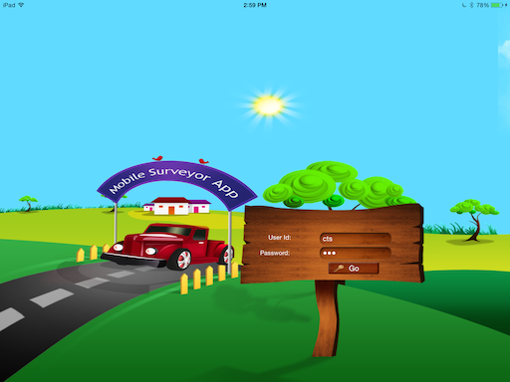

* Sync the Claims From Server Using Sync button/icon on the Screen.

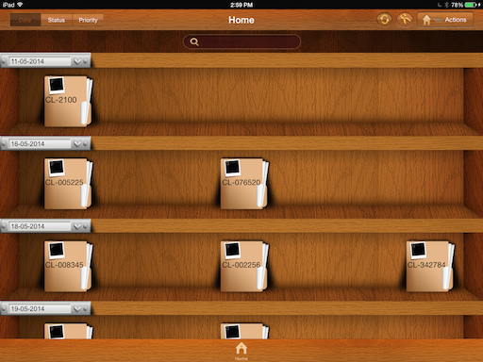

* Once the claims are sync to your IPAD. Please click the any one of the claims or which claim you are done the survey using Google Glass.

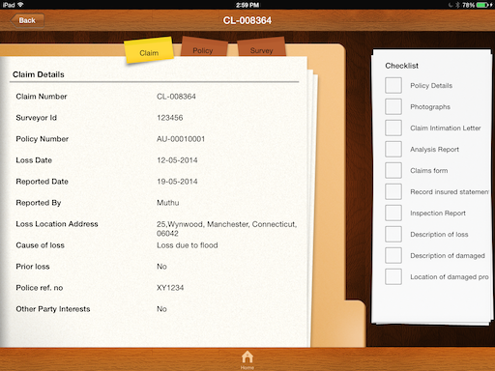

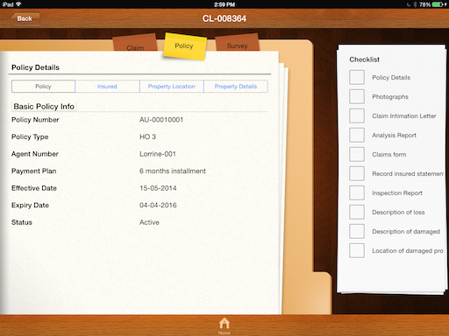

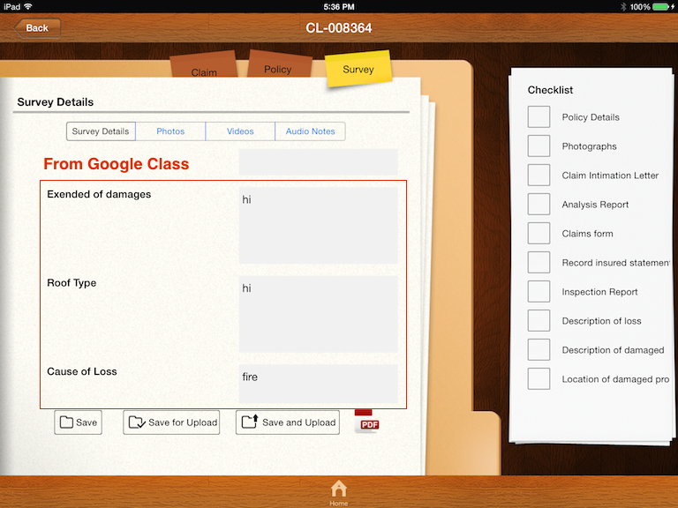

* The below screens are having photos/videos/Audio notes captured by Glass/IPAD

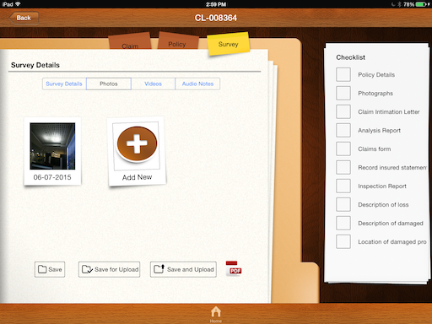

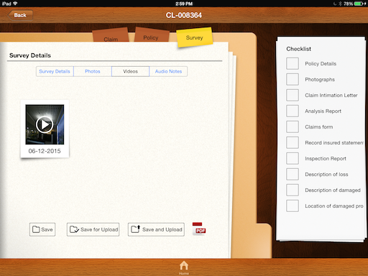

* Please find the updated APK file for Glass.

<https://www.dropbox.com/s/7mweb997y8jvkro/ClaimAdjustment.apk?dl=0>

